Testing failover

______________________________________________________________________________

**Objective:** To test and verify the functionality of HSRP (Hot Standby Router Protocol) failover between R1 and R2 in a high-availability network.

**Scenario:** We simulate the failure of R1, which is the active HSRP router for VLAN 10, and verify that R2 correctly assumes the active role. We also confirm that R1 resumes its active role once recovered.

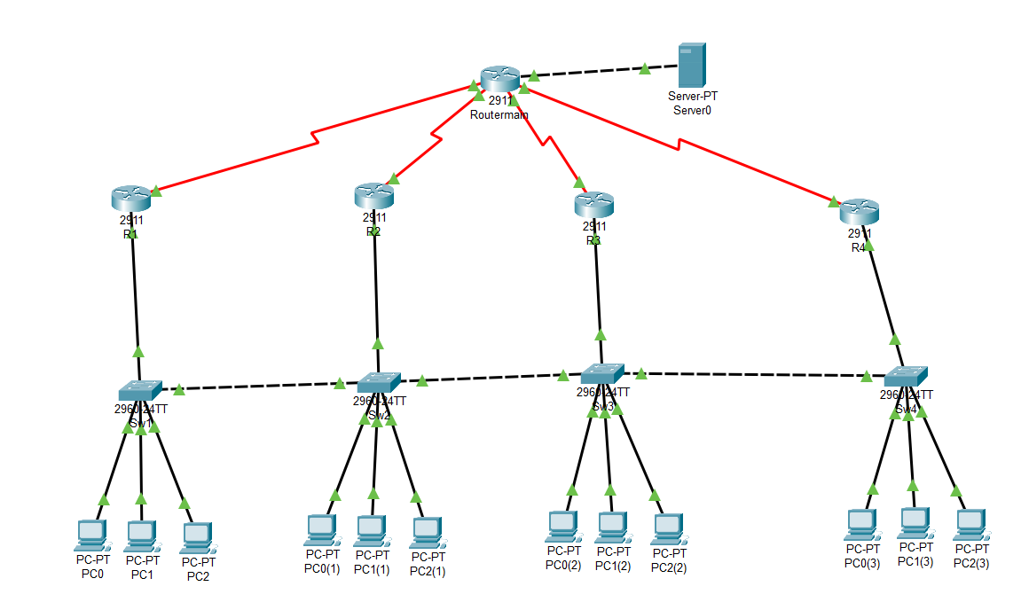

Here we can see that R1 State is Active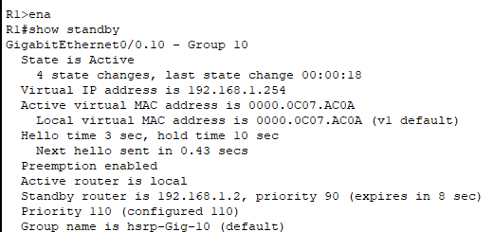

Here we can see that R2 State is Standby

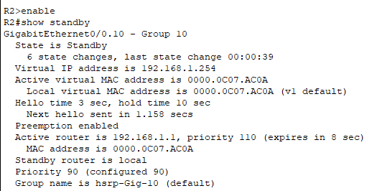

Following our test on R1 we will shut down interface GigabitEthernet0/0 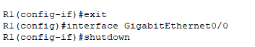

We will use the command show standby again to know if state on R2 will show active

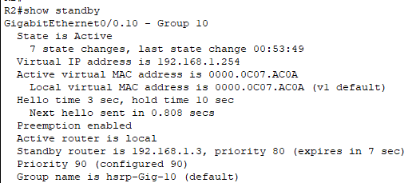

Now we will ping the server(172.16.0.10) from pc0(192.168.1.11) on R1 and use tracert

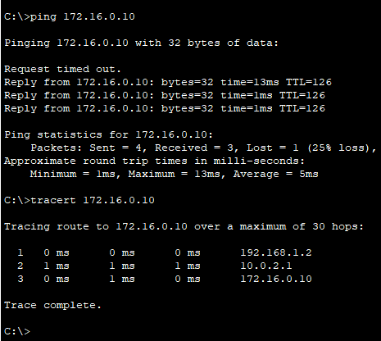

Each hop shows the next device along the route to the server:

1. **Hop 1 → 192.168.1.2**

This is **R2**, the gateway router in VLAN 10.

**Hop 2 → 10.0.2.1**

**This IP address belongs to the serial interface on the Main Router, which is directly connected to R2 over the WAN link.**

**This link uses the 10.0.2.0/30 subnet — specifically:**

**10.0.2.1 → Main Router’s Serial0/0/1 interface**

**10.0.2.2 → R2’s Serial0/0/0 interface**

**Hop 3 → 172.16.0.10**

The **destination server** itself.

Now we will open interface GigabitEthernet0/0 on R1 

We will see it is state it show active using show standby

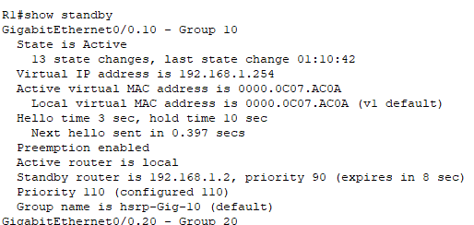

And R2 take it is orgnal state as standby 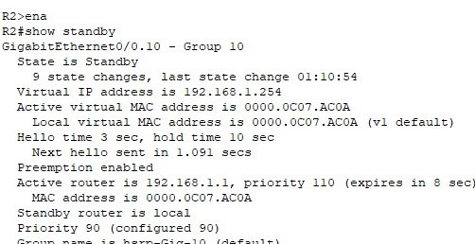

**Explanation for Focusing on R1 and R2:** While the network contains four routers (R1–R4), this test focuses on R1 and R2 only. VLAN 10, where PC0 resides, is handled by R1 and R2. The same HSRP configuration applies to R3 and R4 on other VLANs (e.g., VLANs 30 and 40). Therefore, testing R1 and R2 is sufficient to **prove that the HSRP configuration works**, and additional testing on R3 and R4 would yield the same result.

**Conclusion:** The test confirms that HSRP is correctly implemented between R1 and R2. During R1’s failure, R2 took over gateway responsibilities as expected. When R1 was restored, it resumed its role as Active due to the configured priority and preempt settings. This demonstrates a reliable and fault-tolerant design suitable for high-availability environments.